**Yellow**

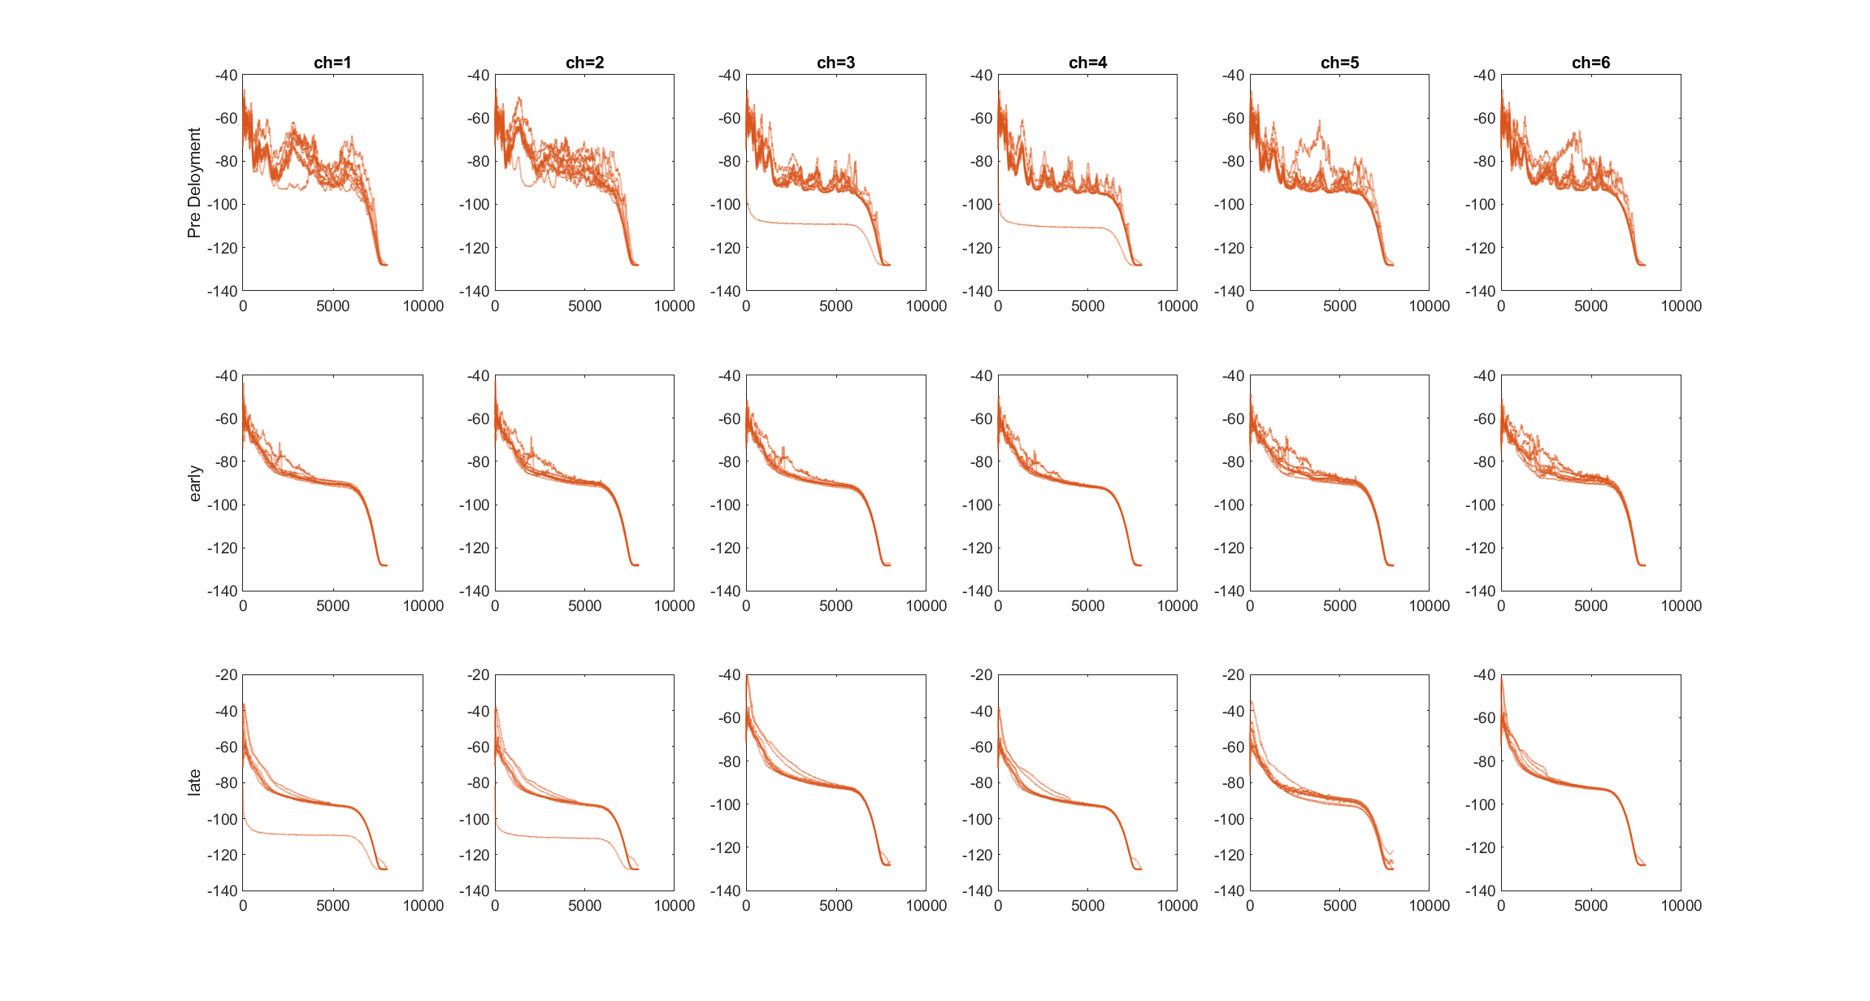

*Notes:* Noise in these recordings is only in 1-2kHz

In pre recordings 1 and 2 are louder and clearer

|  |  |  |  |
| --- | --- | --- | --- |
| Recording no | Pre | Early | Late |
| 1 | Pigeon + tweets | Cheeps | Distant crows, plane |
| BB--BB | BBBBBB | BBBBBB |
| 2 | Chainsaw, Wind | Very Quiet Overall? | Distant Crows |
| BBBBBB | FFFFFF | BBBBBB |
| 3 | Pigeons and other bird | Cheeps | Parakeets |
| BBBBBB | BBBBBB | BBBBBB |
| 4 | Chainsaw | Quiet again Logging? | Very Windy/ Rain? |
| BBBBBB | BBBBBB | BBBBBB |
| 5 | Rain + pigeon | Very clear Chips | Very Windy, Magies |
| BBBBBB | BBBBBB/AAAAAA | BBBBBB |
| 6 | Magpie | Plane Overhead | Squeeky toy bird |
| BBBBBB | BBBBBBB | --BBBB |
| 7 | Chainsaw | Very Clear Trills | Super Windy |
| BBBBBB | BBBBBB/AAAAAA | BBBBBB |
| 8 | Rain and tweets | ***Pure Tones*** and planes? | Magpie |
| BBBBBB | BBBBBB | BBBBBB |
| 9 | Rain and Parakeet | Loggers driving by | Magpie, Crow |
| BBBBBB | BBBBBB | BBBBBB |
| 10 | Pigeon, plane | High pitched bird/ loggers | NA |
| BBBBBB | BBBBBB/AAAAAA | NA |

**Yellowgreen**

*Notes:*

First two channels are **considerable louder** in late in all early **and** late recordings

There also seems to be a band of signal in all the late recordings at around 1kHz (just top 2 channels)

|  |  |  |  |
| --- | --- | --- | --- |
| Recording no | Pre | Early | Late |
| 1 | Chainsaws + bird trills | People Talking Birds | Crows, People |
| BBBBB | CCDDFF | CCFFFF |
| 2 | Chainsaws | Logging | High trills and logging |
| BBBBB | CCFFFF | CCFFFF |
| 3 | Pigeons and tweeting | Tweets, Trills | Parakeets |
| BBBBB | CCFFFF | CCDDFF |
| 4 | Grumbles (possible rain) | Aeroplane/Helicopter | Trills |
| CCCCC | CCDDDF | CCFFFF |
| 5 | Hitting metal | Logging LOUD plane | Birds/ Squirrels |
| BBBBB | CCDDFF | CCFFFF |
| 6 | Chainsaws (eiree echo?) | Tweets, trills, people | Squirrels/ Birds |
| BBBBB | CCFCCF*** | CCFFFF |
| 7 | Bird calls and trills | Trills Logging | Pigeons Trills etc. |
| BBBBB | CCFFFF | CCFFFF |
| 8 | Gardening and Pigeons | Tweets | Trills etc. |
| BBBBB/CCCCC | CCFFFF | CCFFFF |
| 9 | Tweets Chainsaws Gardening | Trills and Tweets | Bird Calls |
| BBBBB | CCFFFF | CCFFFF |
| 10 | Gardening Tweets | Loud Logging. MIC BEING HANDLED. CHAINSAW VERY CLOSE: **14-10-34!** |  |
| BBBBB | CCBBBB |  |

**Green**

*Notes:* 2 seems to be the most sensitive to noise AND signal

Higher frequencies lost when not using channel 2. **This is a consistent problem.**

|  |  |  |  |
| --- | --- | --- | --- |
| Recording no | Pre | Early | Late |
| 1 | Trills | Some distant cheeps | High Trills |
| BBAAAA | DBDDDD | BBBBBB |
| 2 | Wind Cheeps and Pigeon | Some distant calls | Low calls? |
| BBBBBB | DBDDDD | FBFBFF**** |
| 3 | Sparrows? | Wind and pigeons | High trills again |
| BBBBBB | BBBBBB | DCDDDD |
| 4 | Wind and multiple bird calls | Parakeets | Wind and Parakeets |
| BBBBBB | BBBBBB | BBBBBB |
| 5 | High trills | Space gun bird | Parakeets |
| BBBBBB/BBAAAA | BBBBBB | BBBBBB |
| 6 | Loads of clangy birds | Tweets and trills | Parakeets |
| BBBBBB | BBBBBB | BBBBBB |
| 7 | Pigeon/ brit bird | Just wind | Dog barks |
| BBBBBB | BBBBBB | BBBBBB |
| 8 | Trills and tweets | Parakeets | Higher calls |
| BBBBBB | ABAAAA | FBFFFF |
| 9 | Clangy Birds and Wind | Chainsaws and pigeons | Magpie |
| BBBBBB | BBBBBB | BBBBBB |
| 10 | People and high trills | Very high trills and wind | Higher calls |
| BBBBBB | DBDDDD | BBBBBB |

**Blue**

*Notes:* Noise in the late recordings seems a higher pitch than in yellow

Early: not really any discernable signal outside of channel 2. Lots of horizontal lines in spectra

Late: Wind seems a lot more apparent, not sure if I can hear trills or just imagining

|  |  |  |  |
| --- | --- | --- | --- |
| Recording no | Pre | Early | Late |
| 1 | High bird trills and wind | Aeroplane? | Loud Wind |
| FCFFFF | FF--FF | FFF--F |
| 2 | High trills | Wind? | Wind? |
| FCFFFF | FFFF--**** | --FFFF |
| 3 | Trills | Trills? | ?? |
| FCFFFF | FF--FF | FF--FF |
| 4 | Lawnmower + Parakeets | Nothing? Maybe Trills? | Wind… maybe trills??? |
| DCDDDD | FFFFFF | FF--FF |
| 5 | Higher trills, maybe sparrows? | Plane? | Trills?? Wind? |
| FCFFFF | FFFFFF | --FFFF |
| 6 | Higher trills, Pigeon | Parakeet? | Plane? |
| FCFFDF | FF—FF**** | FFFF-- |
| 7 | Trills | Plane? | Wind? Poss Trills? |
| FCFFFF/FCFFDF | FF--FF | FF--FF |
| 8 | REALLY noisy trills | Possible trills and wind | Wind?? |
| DCDDDD | --FFFF | FF--FF |
| 9 | Trills | Car? Trills? Wind? | Maybe trills and wind |
| FCFFFF | FFFF--** | FFFF-- |
| 10 | Really loud and closeby tweeting | ?? | Wind??? |
| FCFFFF | FF—FF**** | FFFF--**** |